Patient Advisory Group: Terms of Reference
- Introduction
European Lung Foundation brings patients and the public together with healthcare professionals to improve lung health and advance diagnosis, treatment, and care. ELF’s vision is that people living with lung conditions will be centrally involved in lung healthcare and research and everyone in Europe will have clear, reliable information they can trust about lung health and disease in their own language. One way we do this is by forming Patient Advisory Groups (PAGs) to contribute to research, drafting of guidelines and other activities. These Terms of Reference set out the aims, membership and practical arrangements of the PAGs.

- Roles and responsibilities of Patient Advisory Groups

  - What is the role of a Patient Advisory Group (PAG)?
A PAG is a group of patients, caregivers and patient organisation representatives who have an interest in a particular lung condition or topic related to lung health. PAGs are set up to contribute to ELF and ERS priority-setting, and input into projects such as Task Forces and Clinical Research Collaborations (CRCs). PAGs may also contribute to other initiatives such as EU projects and ERS assemblies. Some PAGs may initiate their own patient-driven projects. While PAGs function as a group, individual members might also take special responsibilities regarding Task Forces, Clinical Research Collaborations and other projects.

- Task Forces are a group of healthcare professionals set up to produce guidance on diagnosing, treating and managing different lung conditions and symptoms.
- Clinical Research Collaborations are networks of professionals that aim to advance research and improve knowledge in lung conditions and respiratory health. PAGs ensure that patient experiences and issues are considered at all stages of the projects.
- EU projects take different forms, but often bring together a group of researchers, health professionals, industry (e.g. pharmaceutical companies) and patient partners to research a specific topic. It may include for example research priority-setting, a clinical trial, and development of health information materials. PAGs ensure that patient perspectives and priorities are considered.

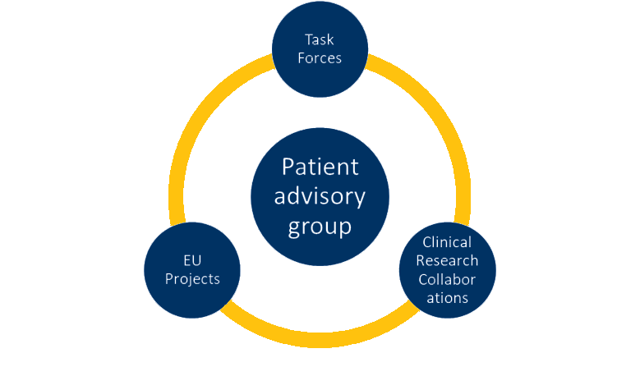

  - What are the responsibilities of a PAG?
PAG members may be involved in the following activities:

- Joining a Steering Committee to provide input into all aspects from a patient or carer perspective
- Commenting on goals to ensure they are relevant to patients and carers
- Providing input on aspects of living with a lung condition that are important to patients and carers to inform guideline recommendations and future research studies
- Offering advice on the best way to hear the views of patients and carers and include them in a project
- Taking part in, and helping to develop, surveys and focus groups to provide the patient and carer perspective
- Helping to disseminate the project findings through their networks to patients, professionals and the public
- Developing patient-facing information materials, such as lay guidelines, patient passports and factsheets
- Developing projects or initiatives to address patient priorities.

- Membership

  - Who can join a PAG?
PAG members represent individuals living with a particular lung condition or topic related to lung health, such as breathlessness. This can include patients, carers, and relatives. Members can be individuals, or representatives of local, national or international groups and organisations. Most members live in Europe but may occasionally be from outside Europe.

  - How are members recruited?
ELF recruits PAG members via notices on its website and in social media, and through its patient and professional networks. Task Force and CRC members may also invite their own patients to join the relevant PAG.

  - Are there any requirements for members?
PAG members should be confident communicating in English, as English is the common language of all ELF activities and communications. We do try to facilitate the involvement of non-native English speakers as far as possible, and hope to eventually offer more opportunities for people to communicate in their native language as we develop the tools to do this. Members must sign a confidentiality agreement and conflict of interest declaration (see item 4). We also encourage all PAG members to complete the European Patient Ambassador Programme (EPAP), a free e-learning programme for patients and carers to develop knowledge and skills in areas of patient representation.

  - Are there any limits on membership?
There is no limit on the length of time a person can be a member of a PAG, but we will periodically review membership to ensure that the group remains relevant to the tasks required.

- Confidentiality and conflict of interest

  - What do members need to agree to?
When joining a PAG, members must sign a form agreeing to keep confidential all information related to the content and development of the projects they are involved with until the outcomes have been published at the end of the project. During the process, patients outside the PAG may be consulted, in which case certain information can be disclosed.

All discussion in PAG meetings should be treated as confidential – particularly in relation to other individuals’ health and personal circumstances.

PAG members are welcome to promote and discuss their activities with ELF though their own channels but should be conscious of confidentiality and privacy. If there is any doubt about whether something should be communicated, the ELF team should be consulted. The ELF team will contact individuals who post information that is deemed to be problematic.

PAG members must declare whether they have any potential conflicts of interest, for example, a relationship with the tobacco/e-cigarette industry or a pharmaceutical company. Members must also tell ELF if, at any point during their membership, a potential conflict of interest arises or may arise.

In order to comply with the funding agreement, EU projects may have additional requirements around confidentiality and conflicts of interest and may have a separate declaration form that PAG members are asked to sign.

  - What if there is a conflict of interest?
While a relationship with the tobacco/e-cigarette industry will usually prevent someone from being accepted as a PAG member, other relationships, such as those with a pharmaceutical company, will not necessarily prevent someone from joining a PAG. The issue will be discussed with the project’s chairs or steering committee and decided on a case-by-case basis.

- PAG meetings

  - When and where will meetings take place?
PAG meetings will usually take place several times a year. These meetings will usually be by video conference. Some meetings may be planned face-to-face when needed and, if possible, at the time of the ERS International Congress.

  - Who attends the meetings?
All members are expected to attend PAG meetings, where possible. An ELF representative normally attends these meetings and will take the minutes. Meetings can be chaired by the ELF representative, or the PAG may choose to nominate a member to chair each meeting. The minutes will be circulated after the meeting for those who were unable to join.

  - United PAG
The United PAG is a PAG made up of members from each of the ELF PAGs. Its purpose is to share ideas and best practice, provide support to each other, help drive ELF’s agenda, and work on projects that are cross-disease topics, such as breathlessness and fatigue. Each PAG is asked to nominate a member to attend the United PAG. United PAG meetings take place every two months and members may be asked to consult with the members of their PAGs between meetings.

- Task Force and CRC meetings

  - When and where will meetings take place?
Task Force and CRC meetings are usually held four times a year, either face to face or by tele/video conference. Face-to-face meetings will take place in an easily accessible European city. One of the yearly meetings will be at the annual ERS International Congress, which is held in a different European city each year. There may be extra Task Force and CRC tele/video conference meetings held throughout the year.

If face-to-face attendance at a meeting is difficult due to health or accessibility, every effort will be made to allow PAG representatives to join remotely.

  - Who attends the meetings?
Usually between one and three people from a PAG attend a Task Force or CRC meeting. Members can nominate themselves to attend or can be nominated by other PAG members or Task Force/CRC members. If there are more members put forward than there are places, the ELF representative will select participants based on factors such as relevant experience and location. An ELF representative will usually attend a Task Force or CRC meeting alongside the PAG representatives.

  - What is expected from attendees?
PAG members attending Task Force and CRC meetings are expected to contribute the patient perspective to discussions, give a balance of views and support each other. They will also be asked to collect input and provide feedback to the ELF representative and the rest of the PAG before and after each meeting, so that their experiences can be used to inform the project and improve patient involvement in future activities.

- EU project meetings

  - When and where will meetings take place?
EU project meetings are usually held several times a year, either face to face or by tele/video conference. The meeting schedule will be set out and agreed within the project grant agreement. Face-to-face meetings will take place in an easily accessible European city, normally once per year. There may be extra tele/video conference meetings held throughout the year.

If face-to-face attendance at a meeting is difficult due to health or accessibility, every effort will be made to allow PAG representatives to join remotely.

  - Who attends the meetings?
The number of patient representatives who attend EU project meetings will vary depending on the budget and plans for patient input agreed with the funders. Usually at least one representative from a PAG will attend an EU project meeting. Members can nominate themselves to attend or can be nominated by other PAG members or EU project members. If there are more members put forward than there are places, the ELF representative and project Chairs will select participants based on factors such as relevant experience and location. An ELF representative will usually attend an EU project meeting alongside the PAG representatives.

  - What is expected from attendees?
PAG members attending EU project meetings are expected to contribute the patient perspective to discussions, give a balance of views and support each other. They will also be asked to collect input and provide feedback to the ELF representative and the rest of the PAG before and after each meeting, so that their experiences can be used to inform the project.

- Communication

8.1 How does the PAG communicate with Task Forces and CRCs?
Each PAG will include an ELF representative who will act as the link between the PAG and Task Forces and CRCs. The ELF representative will support members, arrange meetings, and circulate communications.

8.2 How do the PAG members communicate with each other?
Members are encouraged to exchange email addresses so they can share ideas and experiences between meetings. Other methods of online communication can also be used.

8.3 How are meeting minutes communicated?
Task Force and CRC minutes, along with any relevant documents, will be sent to the PAG representatives after the meeting. Representatives are asked to feed back to other PAG members about the meeting. The ELF representative will take minutes of full PAG meetings and send these to the group.

8.4 What if I have any concerns or worries about my role in the PAG, Task Force or CRC?
If you have worries or concerns about your role in a PAG, you can speak to your ELF representative or the ELF director for help and support.

- Expenses
9.1 What expenses can PAG members claim?
Membership of a PAG is a voluntary role. ELF/ERS will cover the costs of travel, accommodation, food and drink to allow PAG members to attend meetings in person. The cost of telephone calls and video conferencing can also be covered, if needed.

If a meeting is arranged during the ERS Congress and the PAG representative wishes to stay for longer, ELF will not usually cover the full cost of the trip such as extra nights’ accommodation unless this is unavoidable, for example due to flight availability.

Published: January 2021
Date of next review: January 2024

