Bronchiectasis patient conference - Promotion pack
Date: Sunday 12 March 2023
Time: 10:00-16:00 CET
ELF event page: https://europeanlung.org/en/get-involved/events/bronchiectasis-patient-conference-2023/
Registration link: https://www.eventbrite.co.uk/e/bronchiectasis-patient-conference-2023-registration-514708806897
Hashtag: #Bronchiectasis2023
Social media handles | ELF | ERS
Twitter | @EuropeanLung | @EuroRespSoc
Facebook | @europeanlungfoundation | @EuropeanRespiratorySociety
Instagram | @european_lung | @europeanrespiratorysociety
LinkedIn | @European Lung Foundation | @European Respiratory Society

Social media posts:
Platform | Content
Twitter | The @EuropeanLung Foundation is hosting a free online patient conference about bronchiectasis on 12 March.  Learn more about bronchiectasis from healthcare experts and people affected by the condition.  #Bronchiectasis2023  ➡️ https://europeanlung.org/en/get-involved/events/bronchiectasis-patient-conference-2023/
Twitter | I am/We are looking forward to the #Bronchiectasis2023 conference on 12 March hosted by the @EuropeanLung Foundation!  https://europeanlung.org/en/get-involved/events/bronchiectasis-patient-conference-2023/
Facebook | The @European Lung Foundation is hosting a free online patient conference about #Bronchiectasis on 12 March.  This event will be a great opportunity to learn and understand more about bronchiectasis from healthcare experts and people affected by the condition. There will be live presentations and the opportunity to ask the speakers questions.  Key sessions this year will focus on:  - airway clearance techniques,  - the most up-to-date research news, and  - how bronchiectasis affects people through different life stages  #Bronchiectasis2023  Register for free!  ➡️ https://europeanlung.org/en/get-involved/events/bronchiectasis-patient-conference-2023/
LinkedIn | The @European Lung Foundation is hosting a free online patient conference about #Bronchiectasis on 12 March.  This event will be a great opportunity to learn and understand more about bronchiectasis from healthcare experts and people affected by the condition. There will be live presentations and the opportunity to ask the speakers questions.  Key sessions this year will focus on:  - airway clearance techniques,  - the most up-to-date research news, and  - how bronchiectasis affects people through different life stages  #Bronchiectasis2023  Register for free!  ➡️ https://europeanlung.org/en/get-involved/events/bronchiectasis-patient-conference-2023/
Instagram | @european_lung is hosting a free online patient conference about #Bronchiectasis on 12 March.  This event will be a great opportunity to learn and understand more about bronchiectasis from healthcare experts and people affected by the condition. There will be live presentations and the opportunity to ask the speakers questions.  Key sessions this year will focus on:  - airway clearance techniques,  - the most up-to-date research news, and  - how bronchiectasis affects people through different life stages  #Bronchiectasis2023  ➡️ Link in Bio  https://europeanlung.org/en/get-involved/events/bronchiectasis-patient-conference-2023/  #Bronchiectasis #PatientConference
Email | This year ELF are holding their third Bronchiectasis Patient Conference. It will take place virtually on Sunday 12 March 2023 at 10 CET.  The event is open to anyone interested in learning more about bronchiectasis. The conference has been planned with the ELF Bronchiectasis Patient Advisory Group and with clinicians from EMBARC (European Multicentre Bronchiectasis Audit and Research Collaboration).  Key sessions this year will focus on:  - airway clearance techniques,  - the most up-to-date research news, and  - how bronchiectasis affects people through different life stages  Talks will be recorded and made available online after the event.  More details about the event can be found on the ELF event page: https://europeanlung.org/en/get-involved/events/bronchiectasis-patient-conference-2023/  Link to register: https://www.eventbrite.co.uk/e/bronchiectasis-patient-conference-2023-registration-514708806897  If you have any questions, please contact jeanette.boyd@europeanlung.org.

Images:
Twitter
Facebook
Instagram post / LinkedIn | 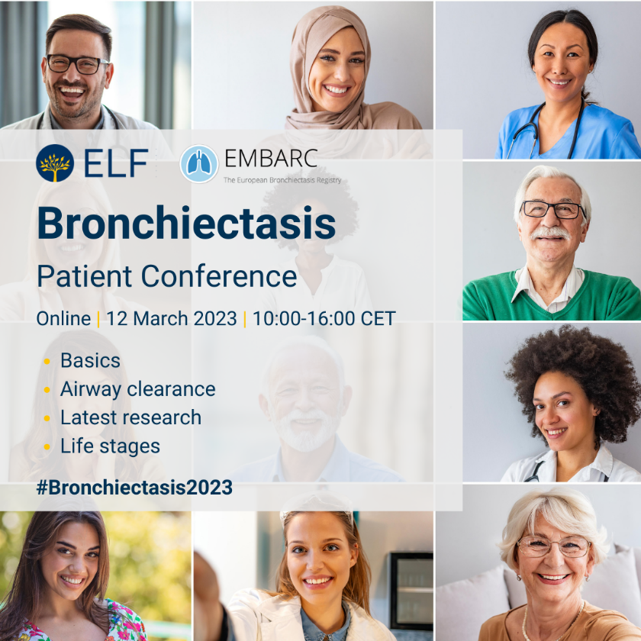
Instagram story | 